REQUEST FOR PROPOSAL
prefabricated concrete
restroom/concession stand facility purchase
Contents:
I. SCOPE OF WORK 1
II. Project Location Map 4
III. SUBMITTAL REQUIREMENTS 5
IV. PROPOSED TIMELINE 6
V. MISCELLANEOUS INFORMATION 6
{ SEAL }
{ SEAL }

SCOPE OF WORK
The Mayor and Commissioners of Emmitsburg, Maryland are requesting sealed bids from qualified contractors for a prefabricated concrete restroom and concession stand combo facility. The restroom facility will be installed in E. Eugene Myers Community Park located at 201 West Lincoln Avenue, Emmitsburg MD 21727. Sealed proposals are due by Monday, February 12, 2024 at 4:00 p.m. Please see “Submittal Requirements” on how to submit your bid.

If desired, vendors may visit the site during regular park hours, sunrise to sunset, to take measurements. See attached map for project location in E. Eugene Myers Community Park. The Town has also completed a Site Plan for the proposed work in April 2023. The Site Plan can be found on the Town website at www.emmitsburgmd.gov under “Public Bidding & RFP.”

Questions? Contact Cathy Willets, Town Manager, at Cwillets@emmitsburgmd.gov. All questions and corresponding answers will be posted in writing on the Town’s website under “Public Bidding & RFP” for bidder reference.

All bids must meet and/or exceed the requirements contained herein. The prefabricated concrete building should be approximately 23-feet x 26-feet in size (or similar) and feature a men and women’s multiuser restroom in one half of the building and a concession stand in the other half of the building with a roll-up concession window and a mechanical chase room. The building shall be pre-plumbed and pre-wired with no exposed wiring. The facility shall meet all Americans with Disabilities Act requirements. The facility shall meet or exceed all local and state permitting requirements. The successful proposer shall provide fully stamped/sealed and approved plans, in full compliance with all state and local permitting.

Exterior of Building shall include:
- All brick, anti-graffiti coating.
- ADA compliant steel commercial grade metal doors.
- ADA/Braille signs.
- Exterior LED lights.
- At least two exterior GFCI receptacles.
- Exterior mounted ADA drinking fountain.
- Exterior frost proof hose bib with box.

Mechanical chase shall include:
- Water heater (specify size in bid).
- Vent openings to circulate air in restroom.
- Unit heaters.
- Vent pipe with rain cover.
- Floor drain.
- Main circuit breaker.
- LED light fixtures.
- At least one GFCI receptacle.
- Cold water hose bib.
- Pressure reducing valve.
- Electrical work for the rest of the building.

Men’s restroom shall include:
- One ADA approved toilet stall with automatic flush valves and ADA grab bars and HDPE stall partition wall and door.
- One urinal with automatic flush valves and HDPE stall partition walls.
- One sink with running hot and cold water and automatic sensor.
- One soap dispenser.
- One three roll jumbo toilet paper holder.
- One baby changing station.
- 4’ LED light fixtures.
- One stainless steel mirror.
- One exhaust fan with occupancy sensor.
- One coat hook.
- One wall hydrant concealed.
- One floor drain.
- One hand dryer.
- Floor will be coated with an epoxy coating to create a non- slip surface. Walls will be painted white.

Women’s restroom shall include:
- One ADA approved toilet stall with automatic flush valves and ADA grab bars and HDPE stall partition wall and door.
- One toilet stall with automatic flush valves and HDPE partition walls.
- One sink with running hot and cold water and automatic sensor.
- One soap dispenser.
- Two three roll jumbo toilet paper holders, one in each stall.
- One baby changing station.
- 4’ LED light fixtures.
- One stainless steel mirror.
- One exhaust fan with occupancy sensor.
- One wall hydrant concealed.
- One floor drain.
- One hand dryer.
- Floor will be coated with an epoxy coating to create a non- slip surface. Walls will be painted white.

Concession side shall include:
- One triple compartment stainless steel sink.
- One hand wash sink.
- One service sink.
- One composite mop sink.
- One 6-foot-wide coiling door for concession with stainless steel counter top.
- One floor drain.
- One exhaust fan with switch.
- LED light fixtures.
- One wall hydrant concealed.
- One unit heater.
- Dedicated receptacles.
- Designated hot water heater (specify size in bid).

Optional items the Town would like, specific cost in bid packet under “detailed cost statement”:
- Marine grade skylights in each restroom.
- Timed electric door locking system on the restrooms.
- Insulation of building.

Miscellaneous Requirements include:
- Supplier shall include transportation cost to the site.
- Supplier shall include installation of the building on an Owner-provided stone pad.
- The owner will be responsible for making all final utility connections.

Project Location Map

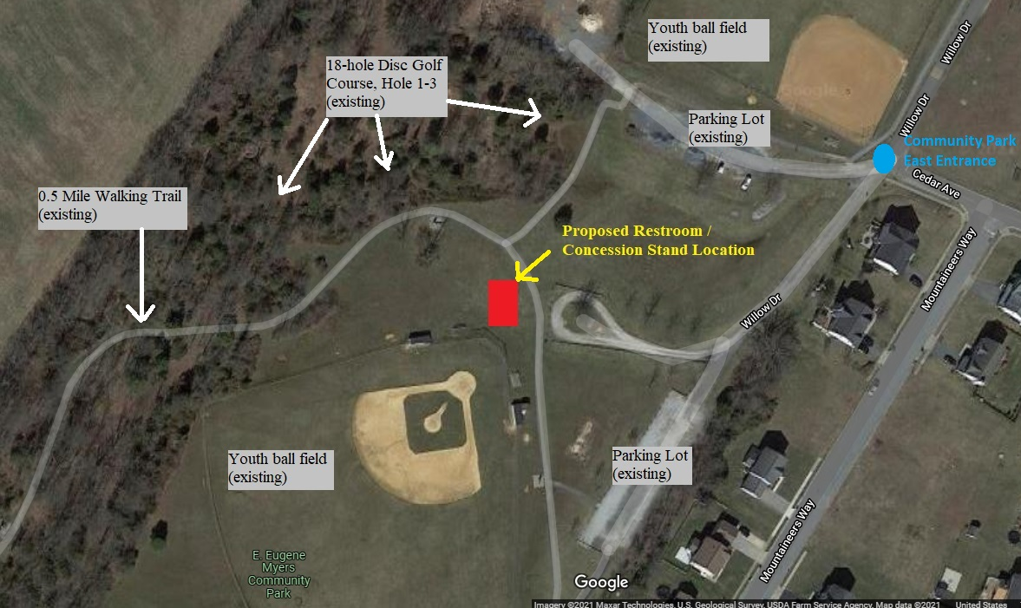

SUBMITTAL REQUIREMENTS
Please submit at least five (5) hard copies of your bid to Town of Emmitsburg, Attn: Town Manager, 300A South Seton Avenue Emmitsburg MD 21727. No email submittals will be accepted. Please note on bids, “RESTROOM BID, Do Not Open.” Contractors can either mail submittals, deliver submittals to the Town Office on the 2nd floor, or place submittals in the black drop box labeled “Town of Emmitsburg” at the rear of the Emmitsburg Community Center (300A South Seton Ave.). If a submittal receipt is requested, please email info@emmitsburgmd.gov or call 301-600-6300. At the minimum, all bids must include the following:

- Letter of Transmittal: The letter of transmittal must contain the following information:
- Name, title, address, e-mail address, and telephone number of the person(s) whom correspondence should be directed regarding the bid and any questions.
- Is unloading and setting the building an option your company provides?
- Statement which indicates “proposal and cost schedule shall be valid and binding for ninety (90) days following proposal due date and will become part of the contract that is negotiated with the Town of Emmitsburg”.

- Detailed cost statement:
Please list the total cost of the building with costs specified for each item. Clearly state any engineering/state fees and transportation costs (if this is something offered). Please note the Town is tax exempt. Clearly state any price exclusions.

- Drawings/specs of proposed building.

- Timeline:
Assuming contract signing by March 18, 2024, give a timeline for building fabrication and building delivery.

- Warranty:
Please describe all warranties that will be provided, including any conditions and response time for repair and/or replacement of any components during the warranty period. Please also indicate the life expectancy under normal use, considering it will be subject to Maryland weather.

- References:
Please provide the name, phone number and email of at least three (3) client references for similar buildings provided within the past three (3) years.

- Proof of Insurance:
The successful proposer must have and maintain current worker’s compensation insurance, comprehensive general liability and automobile insurance for bodily injury, death or loss of or damage to property of third persons in the minimum amount of $1,000,000 per occurrence with the Town of Emmitsburg as an additional name insured. Please list the policy number, insurance company, and expiration date with your bid.

PROPOSED TIMELINE
Mon. January 22, 2024 Request for proposal published.
Mon. February 12, 2024 DEADLINE: Bids due by 4:00 p.m.
Mon. March 4, 2024 Tentative: Bid review/approval by the Board of Commissioners.
Mon. March 18, 2024 Tentative: Contract for purchase of building signed by

MISCELLANEOUS INFORMATION
- The Town of Emmitsburg reserves the right to accept or reject any and/or all bids and to waive any informalities or irregularities in the bidding process.
- The RFP creates no obligation on the part of the Town to award a contract or to compensate the proposer for any costs incurred during the proposal presentation, response, submission, presentation, or oral interviews (if requested/held). The Town reserves the right to award a contract based upon proposals received without further discussion or negotiation. Proposers should not rely upon the opportunity to alter their qualifications during discussions.
- The Town further reserves the right to make investigations as it deems necessary to determine the ability of proposers to furnish the required services, and proposers shall furnish all such information for this proposal as the Town may request.
- Proposers must specifically identify any portion of their submittals deemed to contain confidential or proprietary information.
- The Town of Emmitsburg does not discriminate based on race, color, national origin, sex, sexual orientation, religion, age and disability in employment or the provision of services.

